13.70: Expressing Eq. (13.13) in terms of the frequency, and with 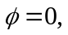and taking two derivatives,
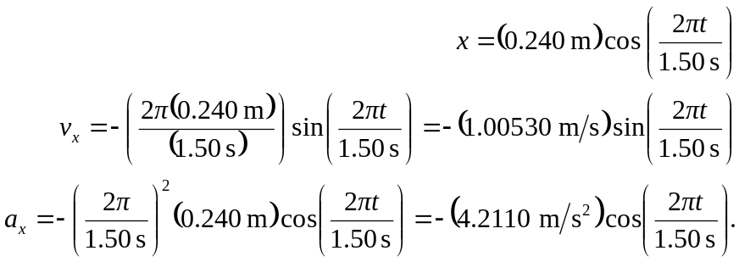

- Substitution gives 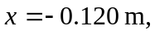 or using 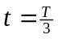gives 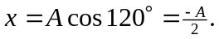
- Substitution gives direction.
- 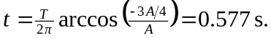
- Using the time found in part (c) , 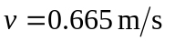(Eq.(13.22) of course gives the same result).

